**Question No.01**

***Physical:*** Saena primarily faces the physical challenges; as a travelling merchant’s daughter, she has learned to fight; she faces the Dark Fae but suffers weakness in her mental defenses against their magic; Aerim learns to fight from Saena and helps her learn to defend herself mentally.

***Magical:*** Aerim is surprisingly resillient to magic and discovers his growing powers as he and Saena venture into the forest to investigate their foe and find the root to the decay of the land; he must ultimately confront the truth that his mother was a Dark Fae and was responsible for introducing a sickness to the human race.

**Question No.02**

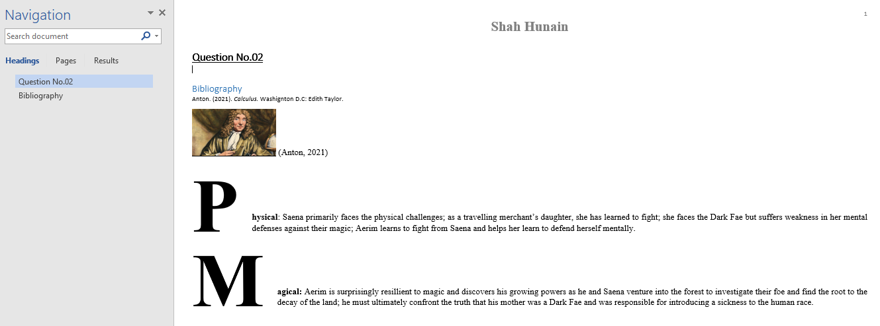

**Question No.03**

**Saena primarily faces the physical challenges; as a travelling merchant’s daughter, she has learned to fight; she faces the Dark Fae but suffers weakness in her mental defenses against their magic; Aerim learns to fight from Saena and helps her learn to defend herself mentally.**

*Aerim is surprisingly* *resillient to magic and discovers his growing powers as he and Saena venture into the forest to investigate their foe and find the root to the decay of the land; he must ultimately confront the truth that his mother was a Dark Fae and was responsible for introducing a sickness to the human race.*

Atoms of radioactive elements can split. According to Albert Einstein, mass and energy are interchangeable under certain circumstances. When atoms split, the process is called nuclear fission. In this case, a small amount of mass is converted into energy. Thus the energy released cannot do much damage. However, several subatomic particles called neutrons are also emitted during this process. Each neutron will hit a radioactive element releasing more neutrons in the process. This causes a chain reaction and creates a large amount of energy.

**Question No.04**

Everyone knows that paper is made from trees. But when one looks at trees, one cannot imagine that something so soft and fragile as the paper is made is so hard and strong. Plant materials such as wood are made of fibres known as cellulose. It is the primary ingredient in paper making. Raw wood is first converted into pulp consisting of a mixture of Cellulose, lignin, water and some chemicals. The pulp can be made mechanically through grinders or through chemical processes. Short fibres are produced by mechanical grinding. The paper produced in this way is weak and is used to make newspapers, magazines and phonebooks.